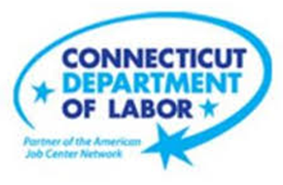

**NEW WEEKLY JOB POSTINGS FROM   
HELP WANTED ONLINE  
Office of Research**

**Week Ending September 24th, 2022:   
Total New Ads Over the Week Decline of 5% Driven by Finance, Insurance, and Health Care.**WETHERSFIELD, September 30th, 2022 – During the week ending September 24th, there were 6,775 new postings, down 321 or -5% over the week. Three industries with the largest over the week declines were Finance & Insurance (-208 new ads), Health Care & Social Assistance (-130 new ads), and Utilities (-121 new ads). Occupations with the largest over-the-week drops include Registered Nurses (-56 new ads), Technical & Scientific Products Sales Representatives (-31 new ads), Janitors & Cleaners (-30 new ads), and Electrical Engineers (-30 new ads). Employers with the largest over the week declines include Yale-New Haven Health System (-151 new ads), PNC Financial Services (-113 new ads), and Trinity Health (-52 new ads). Total weekly new ads in Connecticut and the United States were both down 5% over the week, after increasing by 14% and 7% respectively during the prior week. Note: The Help Wanted Online data series was recently revised to better reflect job posting behavior on some of its source job board websites. This revision resulted in lower total counts for May-August 2022.  
  
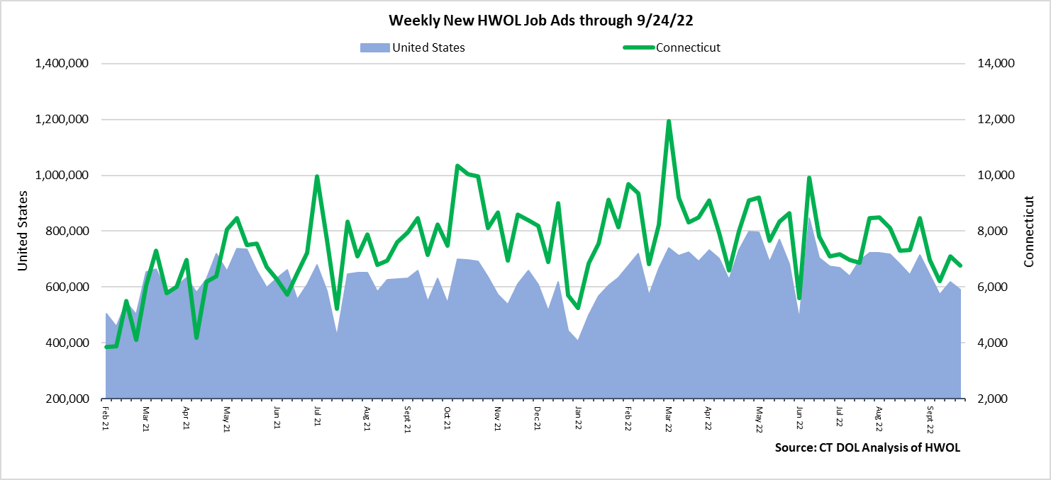  
**Industries** with the most new postings include Health Care & Social Assistance, Retail Trade, and Manufacturing.

**Occupations** with the most new postings include Retail Salespersons, Registered Nurses, Supervisors of Retail Sales Workers.

**Employers** with the most new postings include the State of Connecticut, TJX Companies, Inc. and Yale-New Haven Health System.

**The three industries with the most new job postings were:**

* **Health Care & Social Assistance** (1,075 new postings, -11% over the week)
* **Retail Trade** (725 new postings, +2% over the week)
* **Manufacturing** (657 new postings, -10% over the week)

  
 During the week ending September 24th, 2022, the total ad decreases of 321 new ads or -5% is the net result of decreases in 10 of 21 industries. The 10 decreasing industries fell by a combined 589 new ads and the 11 increasing industries grew by 268. The three industries with the largest over the week declines were Finance & Insurance (-208 new ads), Health Care & Social Assistance (-130 new ads), and Utilities (-121 new ads). Over four weeks, total ads were down 1,436 new ads or -17%. More than half of this overall decline occurred in Health Care & Social Assistance (-744 new ads) and 13 of 21 industries had four-week declines. The largest four week increase among the seven increasing industries occurred in Retail Trade (+92 new ads).  
  
 For more information on total job ads by industry for Connecticut and its labor market areas, see the monthly report available here: <https://www1.ctdol.state.ct.us/lmi/hwol.asp>

**New Job Postings by Occupation** 

**The occupations with the most new postings were:**

* Retail Salespersons (281 new postings, +10% over the week)
* Registered Nurses (203 new postings, -22% over the week)
* Supervisors of Retail Sales Workers (170 new postings, +8% over the week)

**Employers with the Most New Job Postings**

Employers with the most new job postings during the week were mostly in Healthcare & Social Assistance, Finance & Insurance, and Manufacturing. The 25 employers shown above account for 17 percent of all new ads. 19 of 25 employers in the top 25 had over-the-week increases. The largest increases in the top 25 include TJX Companies, Inc. (+103 new ads), State of Connecticut (+73 new ads), and Amazon (+52 new ads). The largest one-week decreases in the top 25 include Yale-New Haven Health System (-151 new ads) and Trinity Health (-52 new ads). Over four weeks, 17 employers in the top 25 increased and 8 decreased. The largest four-week increase occurred at TJX Companies, Inc. (+94 new ads) and the largest four-week decrease occurred at Community Health Center, Inc. (-64 new ads).  
  
**What is HWOL?**The **Conference Board Help Wanted Online**® Data Series (HWOL) measures the number of new, first-time Online job postings and jobs reposted from the previous month for over 16,000 Internet job boards, corporate boards, and smaller job sites that serve niche markets and smaller geographic areas. To view more HWOL data, go to: <https://www1.ctdol.state.ct.us/lmi/hwol.asp>